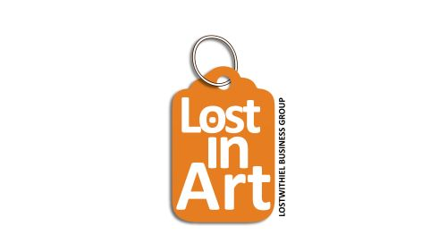
APPLICATION FORM
Name
Trading Name

Address

Telephone Number

Email Address

Are you a member of the Lostwithiel Business Group | Yes/No
Description of your work please include:
When did you start your art/making?
Tell us about your work
What medium, materials do you us?

Please remember to submit 2-3 photos of your work with your application.

Please confirm location you would like to be based at. | Please circle your preference:  Own home/studio/shop  Communal location – such as community centre/scout hall
If you have chosen own home/studio/shop, please give further details such as location, any health and safety concerns, such as access.
Please confirm if you are intending to display your work, sell your work and/or make/do your art whilst you are present.
You can do one or all – its just so we know our end to ensure you have space.

Any other comments

APPLICATIONS WILL ONLY BE CONSIDERED IF THE APPLICATION HAS BEEN COMPLETED IN FULL, PHOTOS OF WORK ARE SUBMITTED AND YOUR INSURANCE DOCUMENT IS ATTACHED.
Many thanks, we will be in touch as soon as we can.

